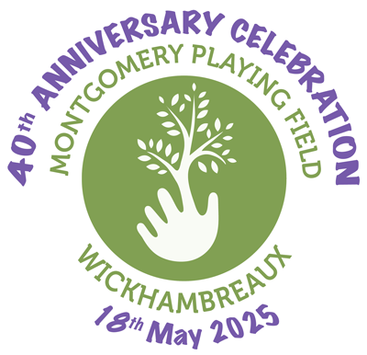 |  | Wickhambreaux Classic Car Show &  40th Anniversary of the Frank Montgomery  Playing Field  Sunday 18th May 2025 – 11am – 4pm  The Frank Montgomery Playing Field, Seaton Road,  Wickhambreaux, Kent. CT3 1RW  wickhambreauxclassiccarshow@gmail.com  Contact Caroline Rees 07432 726273
Classic vehicle / bike booking form – £6 Donation per vehicle or £3 Donation per bike
NAME
ADDRESS
EMAIL / FACEBOOK
PHONE
MAKE & MODEL
REGISTRATION NUMBER |  |  | YEAR OF REGISTRATION
CLUB
PAYMENT METHOD
ADDITIONAL INFORMATION OR SPECIAL REQUIREMENTS

The following conditions apply:
Vehicles should arrive no later than 10.45am and not departing before 4pm. No vehicles to move without a steward.
Owners must be fully insured against third party liability. Entry cost includes 2 persons per car, 1 per bike. Further passengers can pay in advance or at the gate. (Adults £3, youths (12-16) £2, under 12’s free)

Owners must accept responsibility for the welfare of the vehicle and its contents .
I have read and accept the above conditions.
Signed.........................................................Date..........................................
Payments via Paypal (Please use friends & family payment method) using wickhambreauxclassiccarshow@gmail.com
and use your REGISTRATION NUMBER / SURNAME as reference.
Cheques made payable to The Frank Montgomery Playing Field Trust and sent to Caroline Rees 8 Grove Road, Wickhambreaux, Canterbury, Kent. CT3 1SJ.
All proceeds from this Event will be for: The Frank Montgomery Playing Field (for a new goal/basketball net), Wickhambreaux C of E school, Ickham, Wickhambreaux & Stodmarsh Churches.

